<https://medium.com/@gonzalorodriguez_13812/starting-a-simple-web-with-asp-net-core-and-docker-what-are-exactly-e016b7f2a5a3>

Create Azure Container Register

Azure Kubernates service

Note: create VM and install visual studio

Create visual studio project

Publish to azure container registry

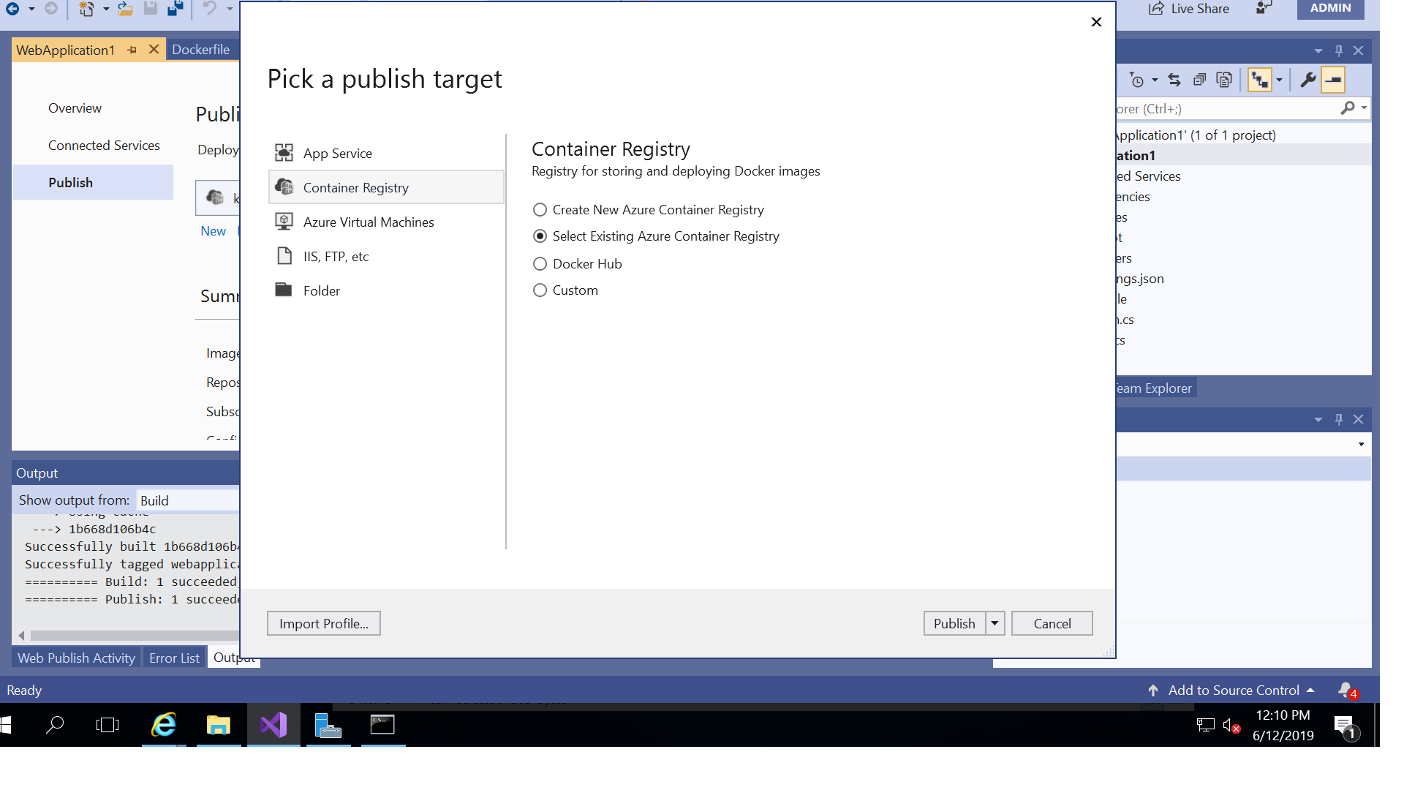

Note: while publishing getting error called unauthorized error

Solution: enable admin user access in container registry

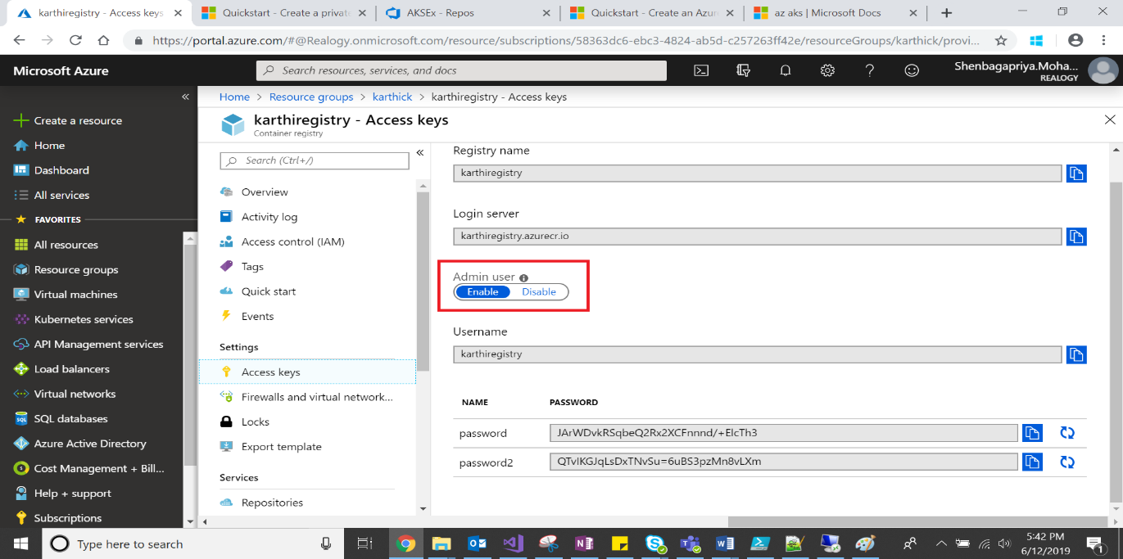

Check whether its deployed or not

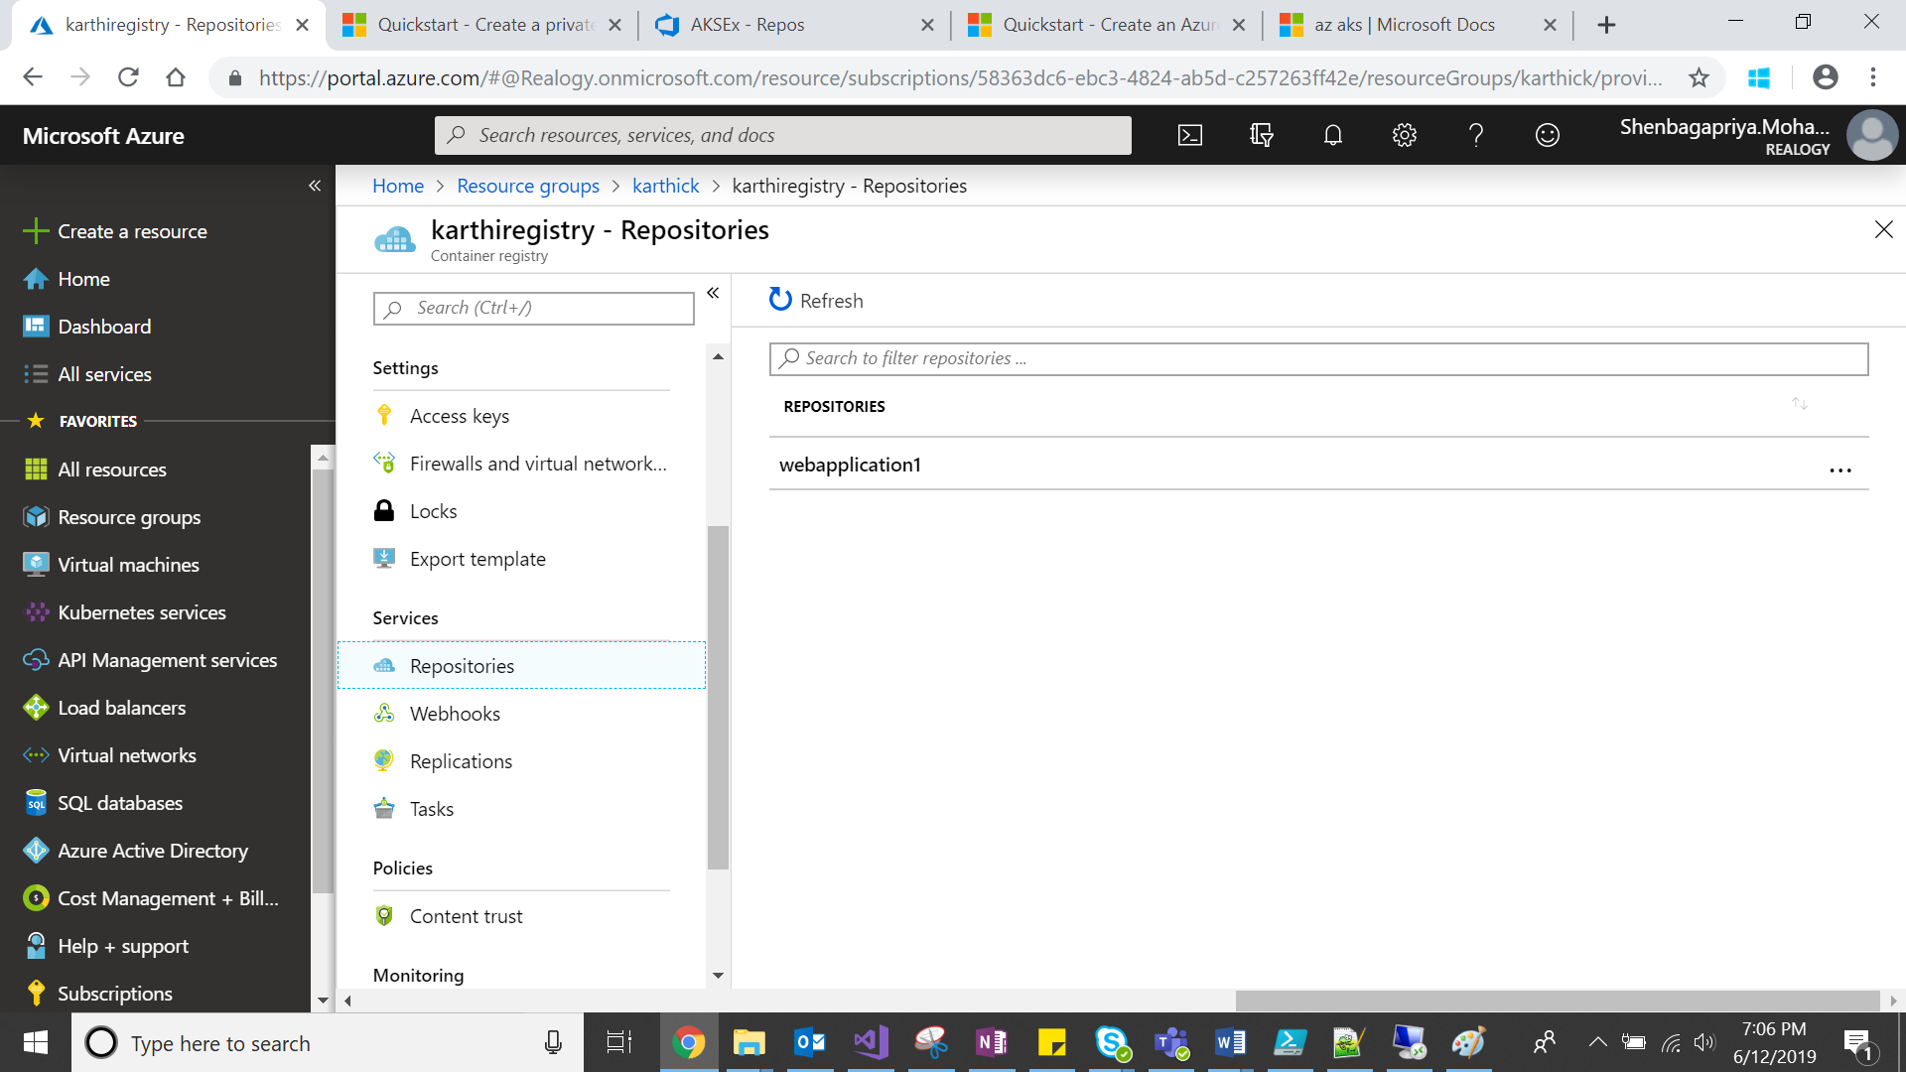

Below commands for install cli and deploy app to cluster

Ref: <https://docs.microsoft.com/en-us/azure/aks/kubernetes-walkthrough>

1. We need to download the kubctl and paste it in D folder
2. Open the cmd and go to D folder
3. Run the following command

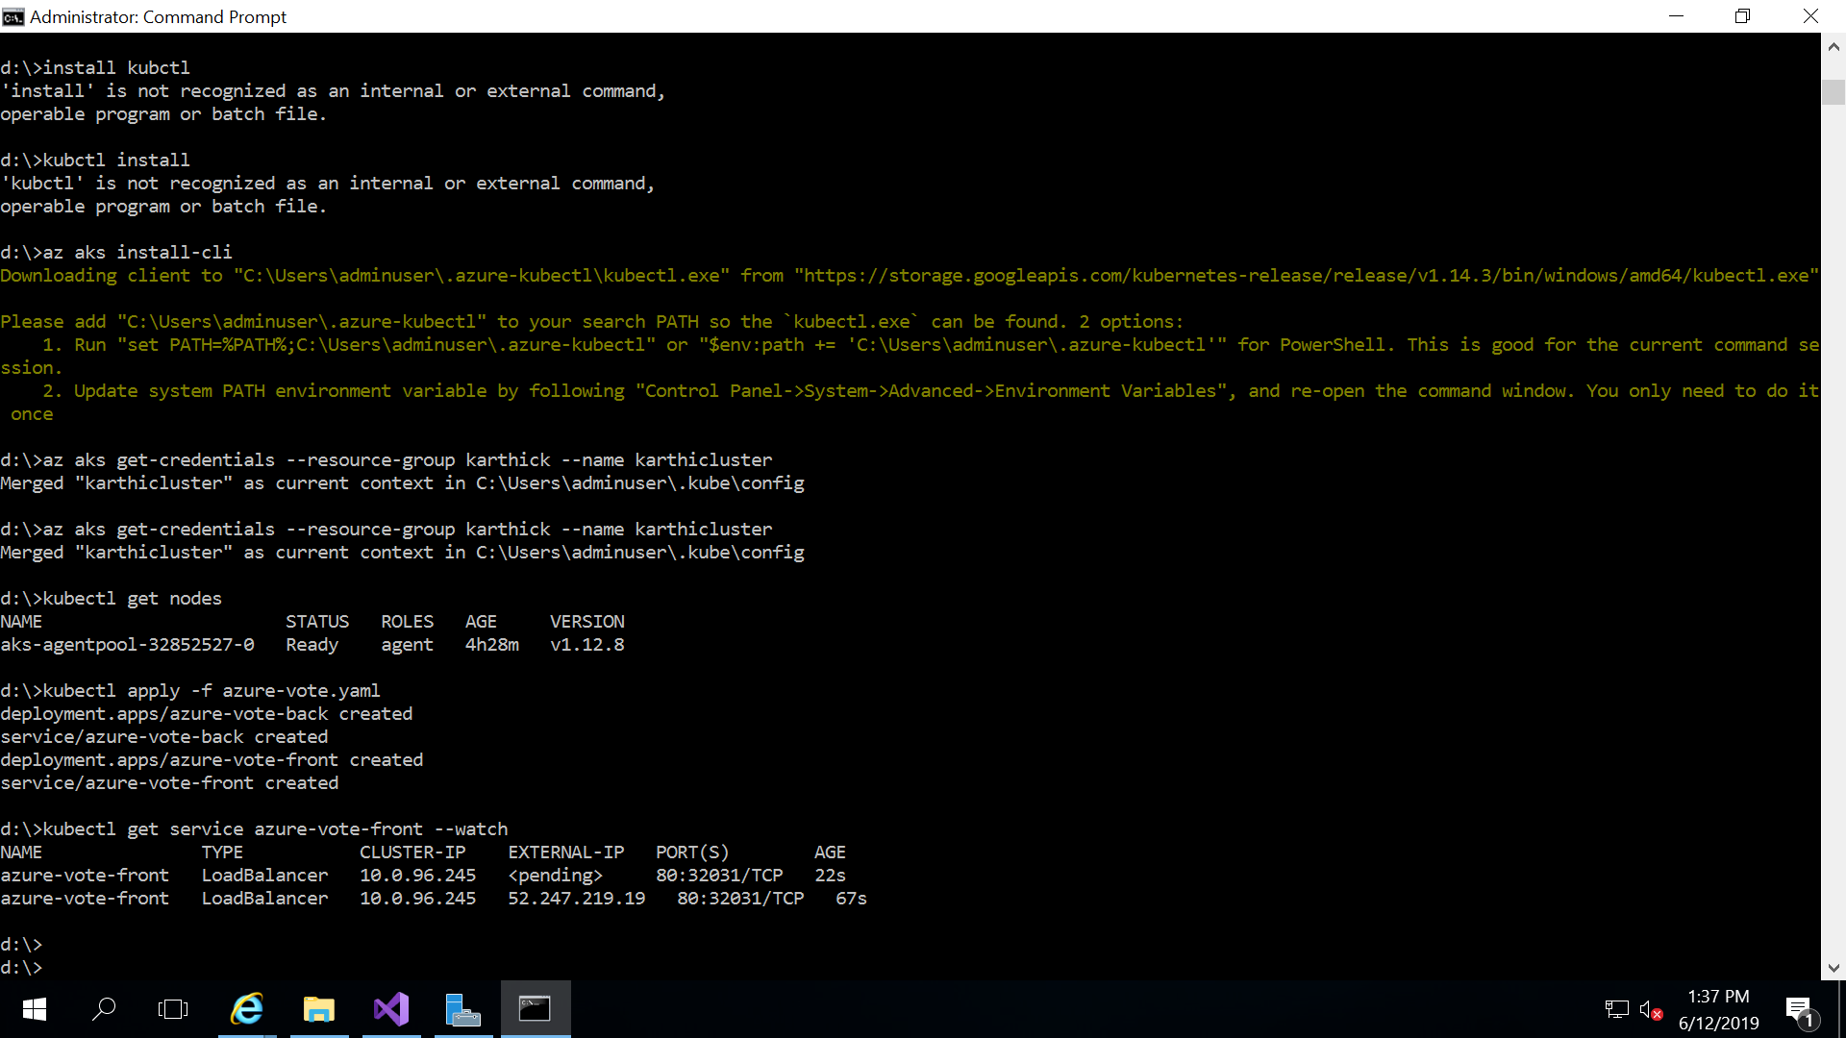

To get kubernetes dashboard run following commands

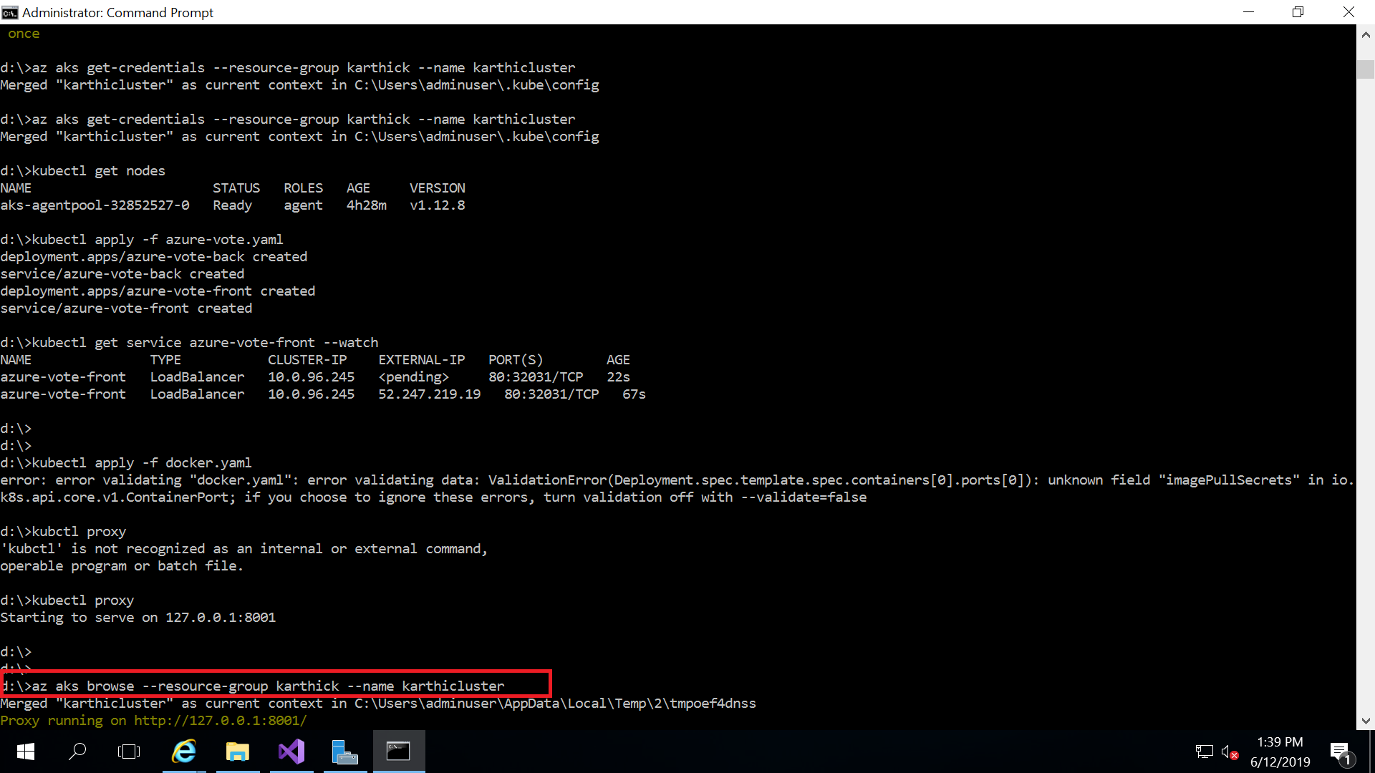

To check the status

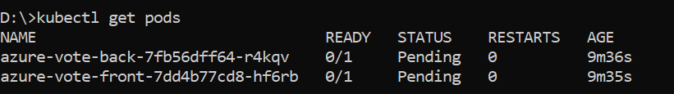

To check the events

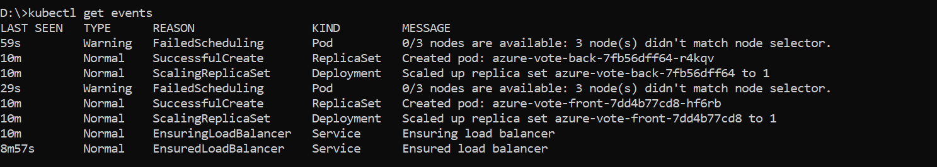

az aks browse --resource-group karthick --name karthicluster

after running this command you will be redirect to dashboard

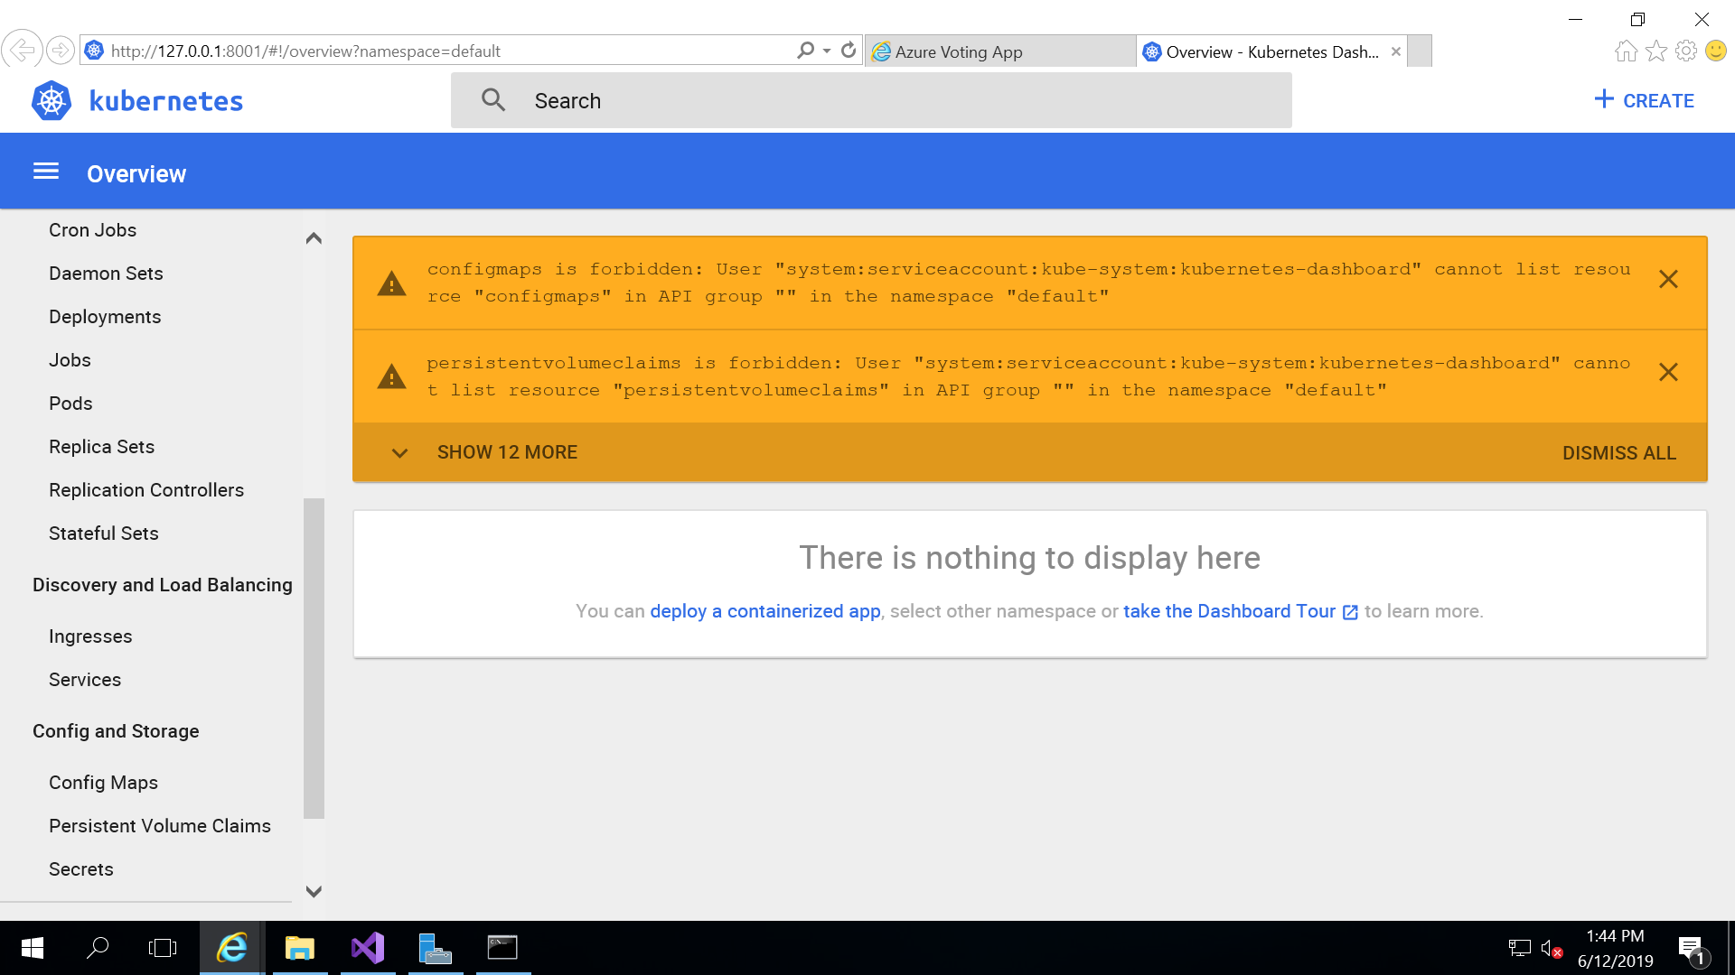

if you want to see app output screen

copy external ip address and paste it in browser

<http://52.247.219.19/>

or

<http://52.247.219.19:80/>